Candidate Resources:
Time and Location:
Residency and Fellowship Poster Showcase – Saturday 11:30am – 1:00 pm MST Convention Center North Building Exhibit Hall A
Professional Placement Forum – Sunday and Monday mornings 8:30 – 11:00 am MST Convention Center North Building, North Ballroom 120 BC
Quicklink to Poster Showcase KEY: https://www.accp.com/docs/meetings/am24/Residency_and_Fellowship_Showcase_Poster_Key.pdf

QR code for quick mobile access to candidate scheduling:
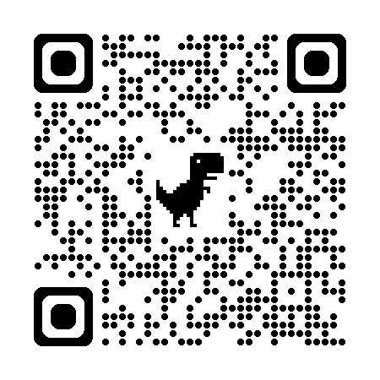

How to determine which programs are available (on which day):
- From main annual meeting webpage or mobile, click on “Professional Placement Forum”:
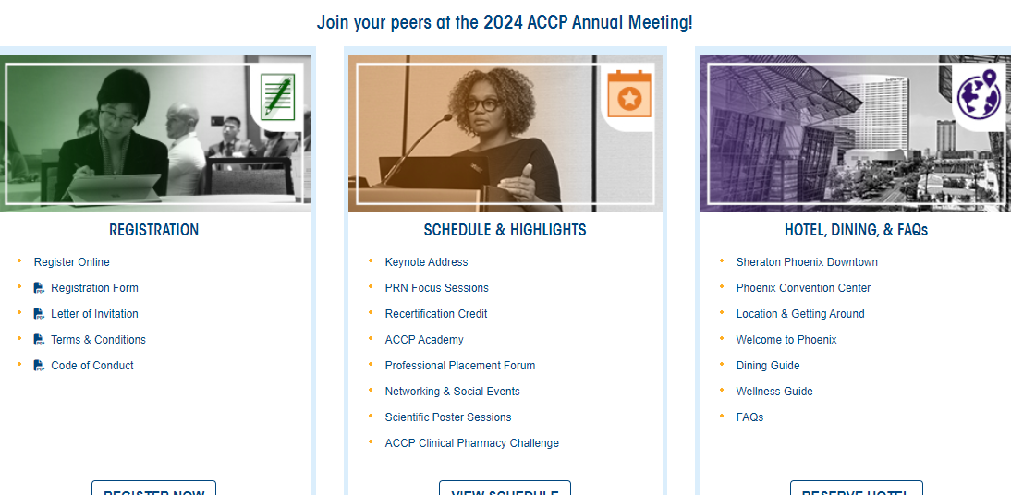

- Select from relevant candidate category (postgrad or practitioner/faculty).
- Click “View Positions”
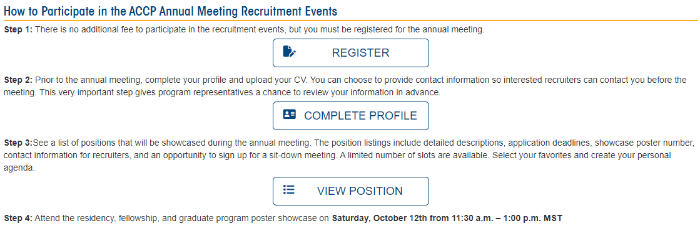

- Select relevant date.
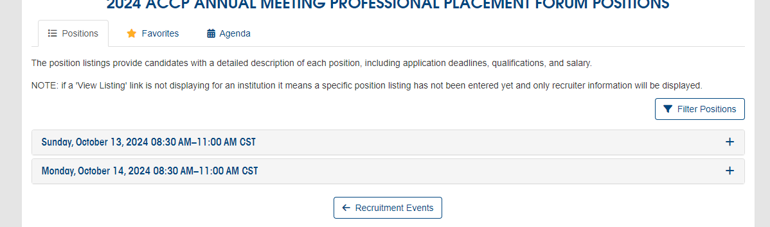
- View position details:
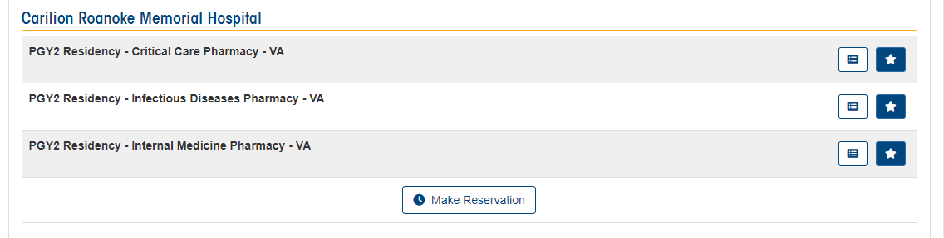

How to make a reservation:
https://www.accp.com/meetings/am24/ppf/positions.aspx
- From within position details, scroll down to reservation sign up.
- Select from available timeslots.
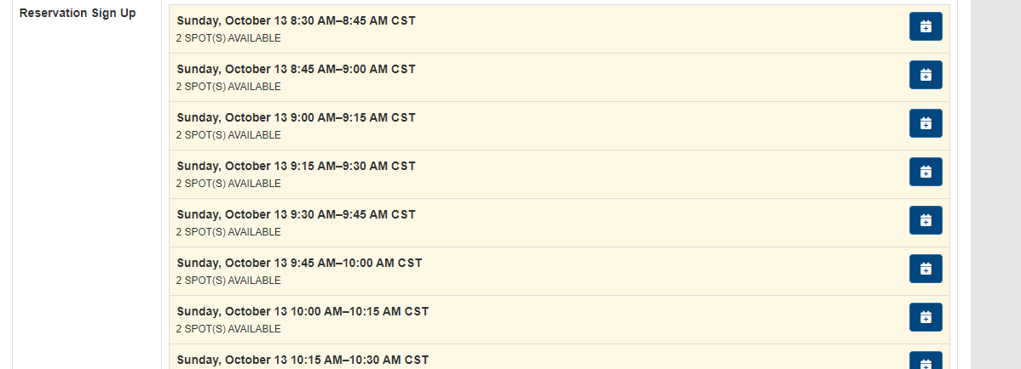

- Find that reservation in your personal agenda:
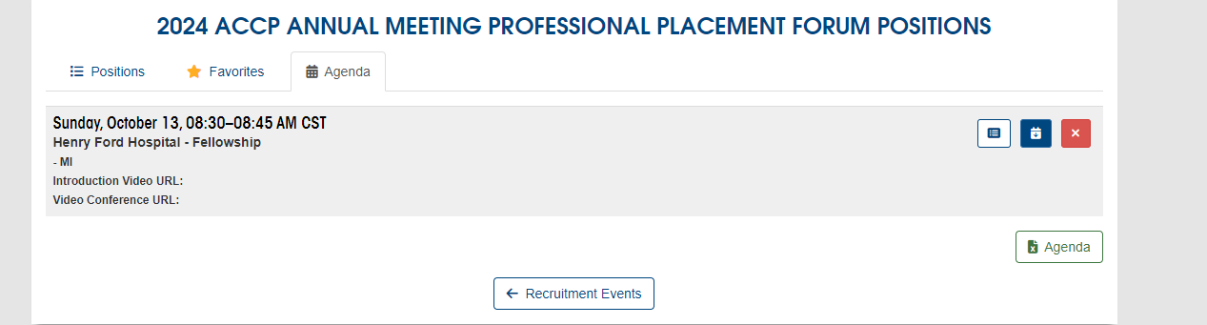

- Use the calendar icon to download to your personal calendar, if desired.
How to cancel a reservation:
- Go to your personal agenda:

- Click on the red X icon to cancel the reservation.

QR code for quick mobile access to candidate scheduling:

